

**RISK GAME (BUILD-1)**

**ARCHITECTURAL DESIGN**

**Advanced Programming Practices**

**SOEN 6441**

**Fall-2019**

**Team: Group_U_J**

Mehul Prajapati (40076930)

Komal Panchal (40130791)

Maryam Giahi (40016260)

Mahmoudreza Entezami (40058782)

Parth Patel (40081116)

Shubham Ranadive (40083991)

Contents

*Introduction* 3

1. Scope 3

1.1 Map Editor: 3

1.2 Game Play: 3

*2. Architecture Design* 4

*3. UML DIAGRAM* 5

4. Modules Description 6

4.1. Config 7

4.2. Entity 7

4.3. Mapparser 7

4.4 Main 8

5. Test Cases (Junit) Description 8

5.1 Main Test 8

5.2 Entity Test 8

5.3 Mapparser Test 8

6. Tools and API 9

7. References: 10

## Introduction

Developed an operational version demonstrating a subset of the capacity of Risk game. It was an effort to implement several extreme programming key features such as Collective ownership, Coding Standards, JavaDoc, Unit Testing and many more.

## 1. Scope

The scope of the build 1 is as per the instruction guidelines for the build:

## 1.1 Map Editor:

* + Create a new map file
  + Edit an existing map file
  + Add/Update/Delete Continent, Country and Adjacent Country
  + Make sure that the integrity of the connected graph is maintained.

## 1.2 Game Play:

* + Assigning country to player
  + Player can assign armies to each country in round robin manner
  + With proper calculation of armies, Reinforcement phase is implemented
  + With a valid fortification move, Fortification phase is implemented

## 2. Architecture Design



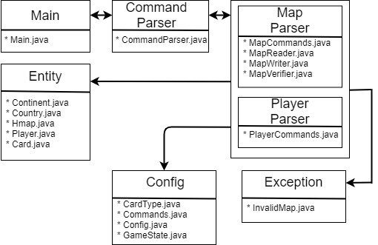

## 3. UML DIAGRAM

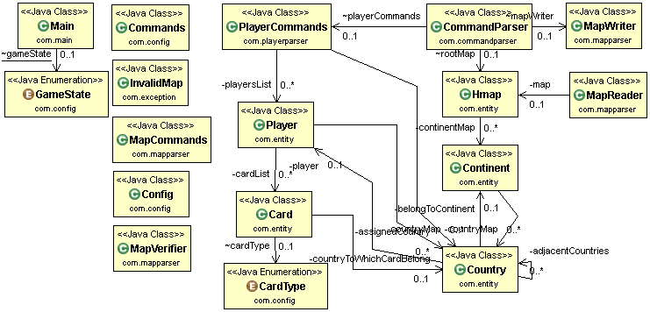

## 4. Modules Description

**Detailed Structure and Explanation**

The overview of project packages is as shown in Screenshot 1.

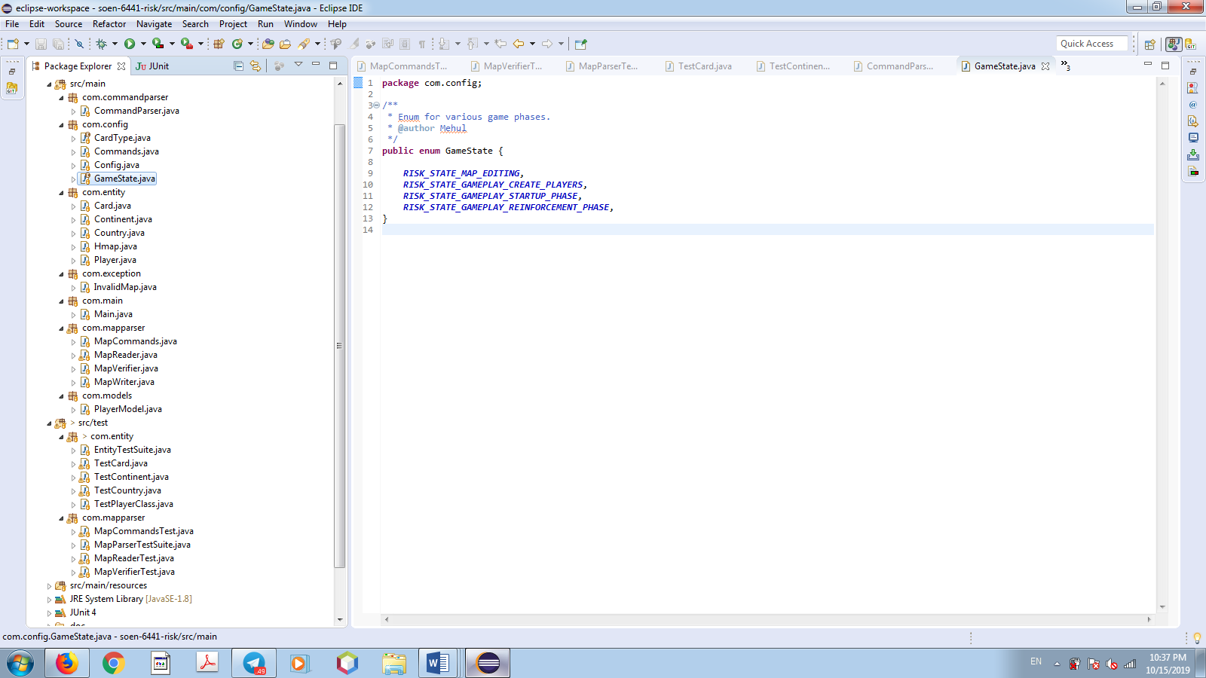



## 4.1. Config

|  |  |
| --- | --- |
| File_name | Description |
| CardType.java | It is a class for cardtype configuration. |
| Commands.java | It is a class for Command configuration. |
| Config.java | It is a class for army configuration . |
| GameState.java | It is a class for GameState configuration. . |

## 4.2. Entity

|  |  |
| --- | --- |
| File_name | Description |
| Hmap.java | It contains all the information of the Map and a list of the continents. |
| Card.java | It contains all the information regarding to Card. |
| Continent.java | It contains all the information of the continent and a list of all the countries that belong to a continent. |
| Country.java | It contains the information of the country like name, a reference to which continent the country belongs, list of all the adjacent country, count of armies currently residing on the country. |
| Player.java | It contains all information related to a player and the number of armies assigned to the player. |

## 4.3. Mapparser

|  |  |
| --- | --- |
| *File_name* | *Description* |
| MapCommand.java | Contains all the common method of the map like: saving map |
| [MapReader.java](https://bitbucket.org/niravjdn/risksoen6441/src/master/src/main/java/com/risk6441/maputils/MapReader.java) | It reads the map file format and parsing in to Map object and checks for the validity of data of the map file. |
| [MapWriter.java](https://bitbucket.org/niravjdn/risksoen6441/src/master/src/main/java/com/risk6441/maputils/MapWriter.java) | It is responsible for writing the Map object to the file. |
| MapVerifier.java | object, opening a dialogue box etc. |

## 4.4 Main

|  |  |
| --- | --- |
| File_name | Description |
| Main.java | Entry point for the application |

## 5. Test Cases (Junit) Description

## 5.1 Main Test

|  |  |
| --- | --- |
| File_name | Description |
| MainTestSuite.java | This is a test class for running all test suits.  ( MapUtilitiesTestSuite.class, GameUtilitiesTestSuite.class,  ModelsTestSuite.class, StrategyTestSuite.class) |

## 5.2 Entity Test

|  |  |
| --- | --- |
| *File_name* | *Description* |
| TestCard.java | This is a test for card class. |
| TestContinet.java | This is a test for continent class. |
| TestCountry.java | This is a test for country class. |
| TestPlayer.java | This is a test for player class. |
| EntityTestSuite.java | This is a test class for running all test suits in Entity  i.e. (TestCard.class, TestContinent.class,  TestCountry.class, TestPlayerClass.class) |

## 5.3 Mapparser Test

|  |  |
| --- | --- |
| *File_name* | *Description* |
| MapcommadTest.java | This is a test class for Map operations |
| Mapreader.java | This is a test class for Map-reader. |
| Mapwriter.java | This is a test class for Map writer. |
| Mapverifier.java | This is a test class for Map verifier. |
| EntityTestSuite.java | This is a test class for running all test suits in Mapparser i.e. (MapcommadTest.class, MapreaderTest.class,  MapwriterTest.class, MapverifierTest.class) |

## 6. Tools and API

|  |  |
| --- | --- |
| *Tools* | *Description* |
| Eclipse | IDE for the game development |
| Git | It is Git code management System which gives one place to plan projects, collaborate on code test and deploy. |
| Junit4 | For writing test class |
| JavaDoc | JavaDoc is a automation tool to generate document to refer regarding libraries and modules of code. |

****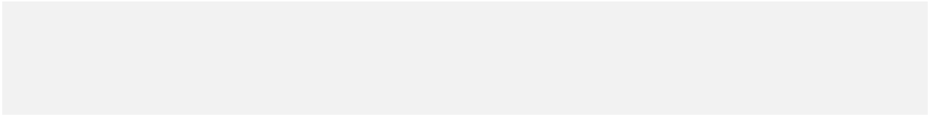********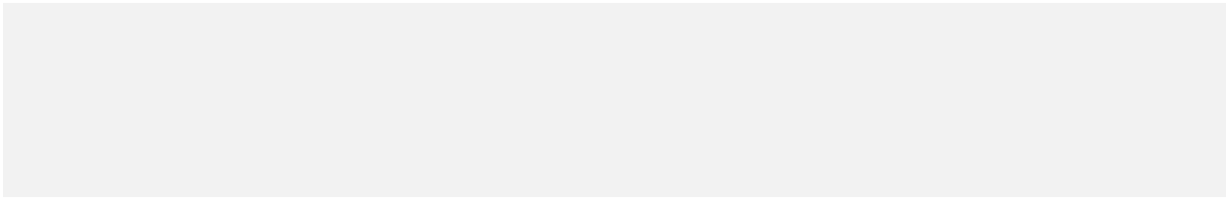

## 7. References:

1. Rules Followed : <https://www.wikihow.com/Play-Risk>
2. <https://sourcemaking.com/refactoring/refactorings>
3. <https://www.sourcetreeapp.com>